

**Wholesale Lift Ticket Booking Instructions**

*Winter 2021/2022*

**URL:** <https://shop.bigskyresort.com/s/wholesale-tickets/c/wholesale-lift-tickets-2>

Each wholesale partner is required to **create an account** that has general contact information attached. Additionally, each partner will be issued an account number that all lift ticket products will be applied to for billing purposes. ***Please note, ONLY lift ticket products receive a NET rate, but lift tickets and rentals can both be charged to the account if you would also like to offer rentals to your client.*** All rates visible in the Wholesale Lift Ticket URL are loaded as **NET (20% off Window Rate).**

**LIFT TICKET BOOKING INSTRUCTIONS**

1. Transactions/Orders must be completed per family or per individual partner reservation and not multiple families under each order.
2. Log into the account first. Once you are logged in, please make sure that it still has “Wholesale Lift Tickets” at the top of the page. If not, please follow the URL back to the Wholesale Portal. When you sign in, it will commonly send you out of the wholesale lift portal.

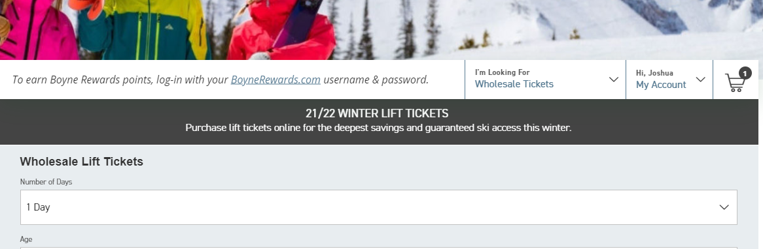

1. Select desired product/s
   1. *Age, Arrival Date, # of days*

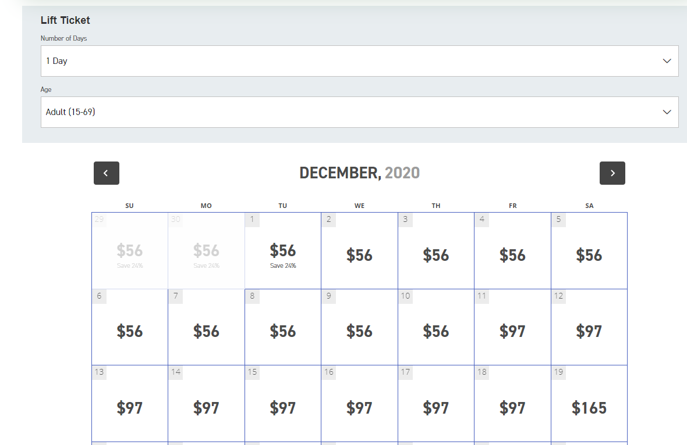

1. Add products to shopping cart, and select additional products for additional guests.
2. When ready to purchase, select *“checkout”*
3. Sign in using company’s account information (if not signed in already)
4. Assign guests to appropriate products by selecting *“Manage your group”, and “add member”.* The initial required information is listed below.

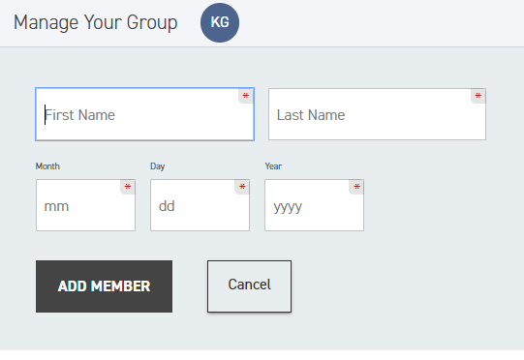

1. Once all products are assigned to the appropriate guests, select *“Continue”.*
2. In order for the guest to purchase a Tram Add-On, additional information is required as noted below. **PLEASE NOTE: this must be the guest’s email, postal & phone and not the wholesale partners.** The waiver can be signed with the authorization by the wholesale partner with the authorization of the guest. If the guest is not pre purchasing the ability to add the tram in, a waiver will not be signed. **The guest will not be contacted by Big Sky Resort directly during this step.**  The guest will personally use this information to log into an account once the Tram Charge Product is created this fall.

I suggest that you fill in this information even if the guest does not currently think they will utilize the tram. If they do not include the information below, they will no longer be able to add this online. They would only be able to add this on once they are onsite.

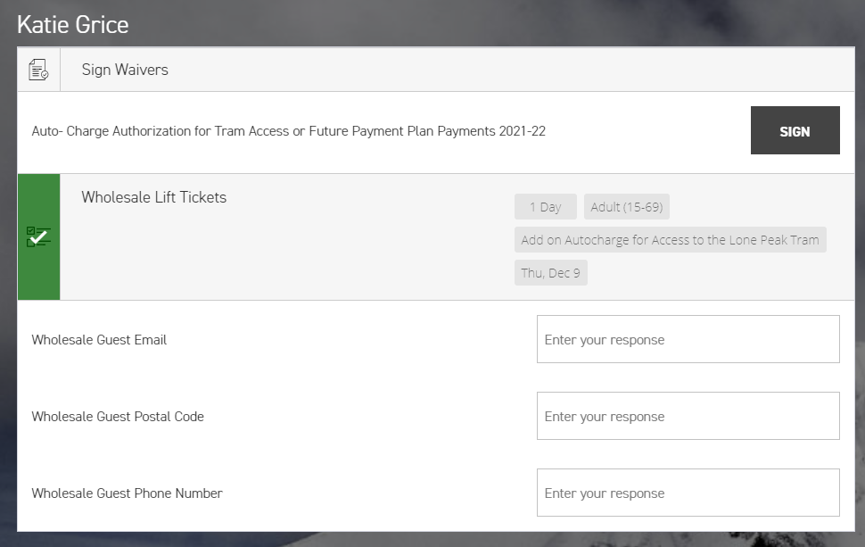

1. Select *“Gift Card or Voucher Number”, and “Apply”.*

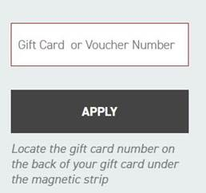

1. Enter account # in the required field
2. Select *purchase* to complete transaction.